T&T Zotero Core Reading List Assignment and Essay
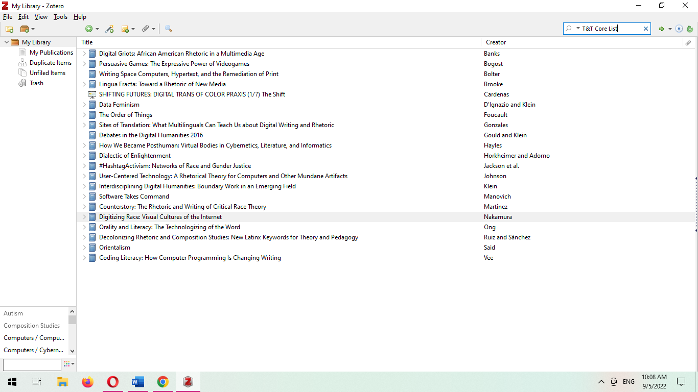
Figure 1 Screenshot of my T&T Core List from Zotero, as haphazardly displayed by MS Word
My present T&T Core Reading List presents a gathering of my interests in rhetoric, feminist and queer/transgender studies, disability studies, and technology, which I hope to in some way connect to build a body of research related to trans rhetorics and adaptive/gender affirming technology as part of the trans experience. In many cases, I selected these works based on some cursory knowledge or the title alone. Others, such as Said’s Orientalism or Foucault’s The Order of Things, I’ve had the privilege of working with in another context (Said; Foucault). Though Said’s ‘Other’ was not created to embrace a ‘transgender other’, the heteronormative othering of trans experiences and bodies is central to my thinking (Said). In addition, I have included the required reading list for Introduction to Texts and Technology (Bogost; Bolter; Gould and Klein; Vee; Nakamura; Manovich; Klein), as well as a few pieces that my mentors from my earlier graduate school experiences encouraged me to pick up that also appeared on the T&T Core Reading list, such as Lingua Fracta (Brooke).
More contextually appropriate contributions to my research appear from Data Feminism, #HashtagActivism, and How We Became Posthuman, each of which in some way work with gendered and embodied experiences (D’Ignazio and Klein; Jackson et al.; Hayles). Of particular interest to me, however, is the Digital Humanities project Shifting Futures: Digital Trans of Color Praxis by Micha Cardenas, not just for its content but for its form and its use of the Scalar platform (Cardenas). Additional pieces that piqued my interest as they relate to rhetoric or composing include Digital Griots, Decolonizing Rhetoric & Composition Studies, Counterstory, Sites of Translation, and User-Centered Technology (Banks; Ruiz and Sánchez; Martinez; Gonzales; Johnson).

Works Cited
Banks, Adam J. Digital Griots: African American Rhetoric in a Multimedia Age. SIU Press, 2011.
Bogost, Ian. Persuasive Games: The Expressive Power of Videogames. MIT Press, 2010.
Bolter, Jay David. Writing Space Computers, Hypertext, and the Remediation of Print. 2nd ed., Routledge Lawrence Erlbaum, 2011.
Brooke, Collin Gifford. Lingua Fracta: Toward a Rhetoric of New Media. Hampton Press, 2009.
Cardenas, Micha. SHIFTING FUTURES: DIGITAL TRANS OF COLOR PRAXIS (1/7) The Shift. https://scalar.usc.edu/works/shifting-futures-micha-cardenas/the-flicker?path=index.
D’Ignazio, Catherine, and Lauren F. Klein. Data Feminism. MIT Press, 2020.
Foucault, Michel. The Order of Things. Routledge, 2005.
Gonzales, Laura. Sites of Translation: What Multilinguals Can Teach Us about Digital Writing and Rhetoric. University of Michigan Press, 2018.
Gould, Matthew K., and Lauren F. Klein, editors. Debates in the Digital Humanities 2016. University of Minnesota Press, 2016.
Hayles, N. Katherine. How We Became Posthuman: Virtual Bodies in Cybernetics, Literature, and Informatics. University of Chicago Press, 1999.
Jackson, Sarah J., et al. #HashtagActivism: Networks of Race and Gender Justice. MIT Press, 2020.
Johnson, Robert R. User-Centered Technology: A Rhetorical Theory for Computers and Other Mundane Artifacts. SUNY Press, 1998.
Klein, Julie T. Interdisciplining Digital Humanities: Boundary Work in an Emerging Field. University of Michigan Press, 2015.
Manovich, Lev. Software Takes Command. A&amp;C Black, 2013.
Martinez, Aja Y. Counterstory: The Rhetoric and Writing of Critical Race Theory. Conference on College Composition and Communication, 2020.
Nakamura, Lisa. Digitizing Race: Visual Cultures of the Internet. U of Minnesota Press, 2007.
Ruiz, Iris D., and Raúl Sánchez. Decolonizing Rhetoric and Composition Studies: New Latinx Keywords for Theory and Pedagogy. Springer, 2016.
Said, Edward W. Orientalism. Knopf Doubleday Publishing Group, 2014.
Vee, Annette. Coding Literacy: How Computer Programming Is Changing Writing. MIT Press, 2017.

